Leading University, Sylhet
Department of Computer Science & Engineering
Mid-Term; spring – 17

1.
a.
Protocol:
When computers communicate with each other, there needs to be a common set of rules and instructions that each computer follows. A specific set of communication rules is called a protocol.
Encapsulation:
The term “encapsulation” is used to describe a process of adding headers and trailers around some data. For example, when you send an email using your favorite email program that email is sent from the Application layer to the Transport layer. The Transport layer encapsulates the data and adds its own header and passes the data to the Internet layer, which again encapsulates the received data and adds its own header, usually with information about the source and destination IP addresses. The Internet layer than passes the data to the Network Access layer. This layer is the only layer that adds both a header and a trailer. The data is then sent through a physical network link.
Segmentation:
Segmentation is the term used to describe the process of chopping streams of data into smaller chunks. Segmentation usually occurs fairly early in the communication process and it is almost always software that performs the segmentation process. The segmentation process is performed prior to transfer of data across a network or before storage on a peripheral device. Segmentation is necessary because today's communication systems use what is called packetized communication.
Reassembly
Reassembly is the reverse of segmentation. Protocol Data Units are put back together in the correct order to reassemble a stream of data in its original form.

b.

c.
Principle of Network OSI Layers:
Application (Layer 7):
This layer supports application and end-user processes. Communication partners are identified, quality of service is identified, user authentication and privacy are considered, and any constraints on data syntax are identified. Everything at this layer is application-specific. This layer provides application services for file transfers, e-mail, and other network software services. Telnet and FTP are applications that exist entirely in the application level. Tiered application architectures are part of this layer.
Presentation (Layer 6)
This layer provides independence from differences in data representation by translating from application to network format, and vice versa. The presentation layer works to transform data into the form that the application layer can accept. This layer formats and encrypts data to be sent across a network, providing freedom from compatibility problems. It is sometimes called the syntax layer.
Session (Layer 5)
This layer establishes, manages and terminates connections between applications. The session layer sets up, coordinates, and terminates conversations, exchanges, and dialogues between the applications at each end. It deals with session and connection coordination.
Transport (Layer 4)
This layer provides transparent transfer of data between end systems, or hosts, and is responsible for end-to-end error recovery and flow control. It ensures complete data transfer.
Network (Layer 3)
This layer provides switching and routing technologies, creating logical paths, known as virtual circuits, for transmitting data from node to node. Routing and forwarding are functions of this layer, as well as addressing, internetworking, error handling, congestion control and packet sequencing.
Data Link (Layer 2)
At this layer, data packets are encoded and decoded into bits. It furnishes transmission protocol knowledge and management and handles errors in the physical layer, flow control and frame synchronization. The data link layer is divided into two sub layers: The Media Access Control layer and the Logical Link Control layer. The MAC sub layer controls how a computer on the network gains access to the data and permission to transmit it. The LLC layer controls frame synchronization, flow control and error checking.
Physical (Layer 1)
This layer conveys the bit stream - electrical impulse, light or radio signal -- through the network at the electrical and mechanical level. It provides the hardware means of sending and receiving data on a carrier, including defining cables, cards and physical aspects. Fast Ethernet, RS232, and ATM are protocols with physical layer components.

2.
a.
Analog Signal:
Analog signal is a continuous electrical signal in the form of wave. The wave is known as carrier wave. Telephone line is most commonly used media for analog signals.
Digital Signals
Digital signal is a sequence of voltage represented in binary form. The digital signals are in the form of electrical pulses of ON and OFF. These signals are in discrete form. Digital signals are faster and efficient. They provide low error rates. They also provide high transmission speed and high-quality voice transmission.
Frequency:
Frequency, it’s something that happens over and over and over again. It is very frequent, consistent, and repetitive.

Amplitude:
Amplitude is the height, force or power of the wave.

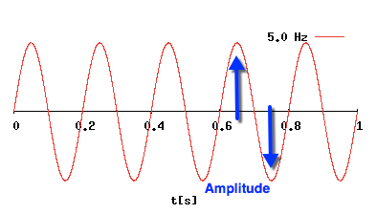

Wavelength:
Wavelength is the distance between similar points on two back-to-back waves.

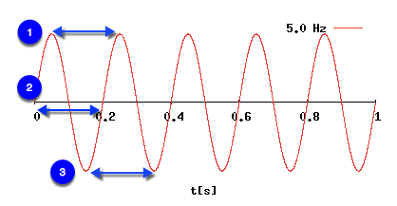

b.
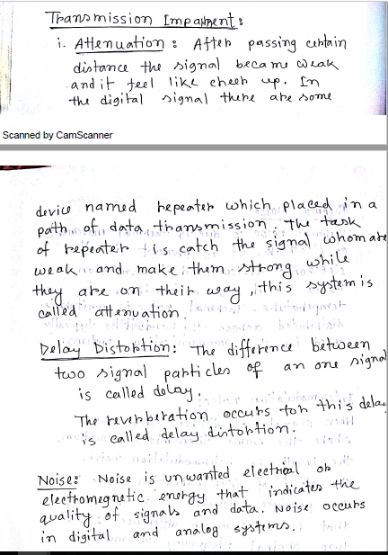

c.
Nyquist Formula & Shannon Capacity Formula:
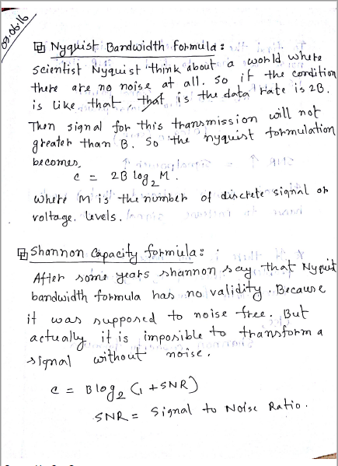
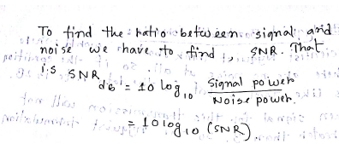

3.
a.
Optical Fiber:
Fiber optics, or optical fiber, refers to the medium and the technology associated with the transmission of information as light pulses along a glass or plastic strand or fiber. A fiber optic cable can contain a varying number of these glass fibers -- from a few up to a couple hundred. Surrounding the glass fiber core is another glass layer called cladding. A layer known as a buffer tube protects the cladding, and a jacket layer acts as the final protective layer for the individual strand.

Work Process:
Light travels down a fiber-optic cable by bouncing repeatedly off the walls. Each tiny photon (particle of light) bounces down the pipe like a bobsleigh going down an ice run. Now you might expect a beam of light, traveling in a clear glass pipe, simply to leak out of the edges. But if light hits glass at a really shallow angle (less than 42 degrees), it reflects back in again—as though the glass were really a mirror. This phenomenon is called total internal reflection. It's one of the things that keeps light inside the pipe.
The other thing that keeps light in the pipe is the structure of the cable, which is made up of two separate parts. The main part of the cable—in the middle—is called the core and that's the bit the light travels through. Wrapped around the outside of the core is another layer of glass called the cladding. The cladding's job is to keep the light signals inside the core. It can do this because it is made of a different type of glass to the core.
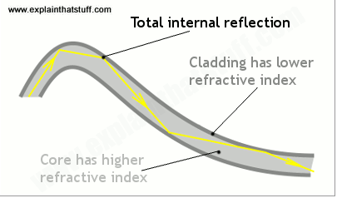
Applications of Optical Fibers:
Internet, Cable Television, Telephone, Computer Networking, Lighting & Decoration.

b.
Satellite Microwave:
A communication satellite is, in effect, a microwave relay station. It is used to
Link two or more ground-based microwave transmitter/receivers, known as earth
Stations, or ground stations. The satellite receives transmissions on one frequency
band (uplink), amplifies or repeats the signal, and transmits it on another frequency
(downlink). A single orbiting satellite will operate on a number of frequency bands,
Called transponder channels, or simply transponders.

Terrestrial Microwave:
The most common type of microwave antenna is the parabolic “dish.” A typical
size is about 3 m in diameter. The antenna is fixed rigidly and focuses a narrow
beam to achieve line-of-sight transmission to the receiving antenna. Microwave antennas
are usually located at substantial heights above ground level to extend the
range between antennas and to be able to transmit over intervening obstacles. To
achieve long-distance transmission, a series of microwave relay towers is used, and
point-to-point microwave links are strung together over the desired distance.

c.
Frequency Hopping Spread Spectrum (FHSS):
Frequency hopping spread spectrum (FHSS) is a method of transmitting radio signals by shifting carriers across numerous channels with pseudorandom sequence which is already known to the sender and receiver.
Frequency hopping spread spectrum is defined in the 2.4 GHz band and operates in around 79 frequencies ranging from 2.402 GHz to 2.480 GHz. Every frequency is GFSK modulated with channel width of 1MHz and rates defined as 1 Mbps and 2 Mbps respectively.

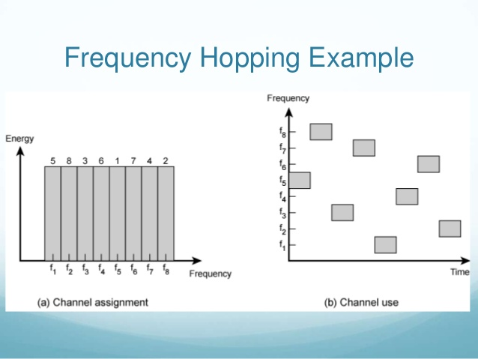

Direct sequence spread spectrum (DSSS):
Direct sequence spread spectrum, also known as direct sequence code division multiple access, is one of two approaches to spread spectrum modulation for digital signal transmission over the airwaves. In direct sequence spread spectrum, the stream of information to be transmitted is divided into small pieces, each of which is allocated across to a frequency channel across the spectrum. A data signal at the point of transmission is combined with a higher data-rate bit sequence (also known as a chipping code) that divides the data according to a spreading ratio. The redundant chipping code helps the signal resist interference and also enables the original data to be recovered if data bits are damaged during transmission.
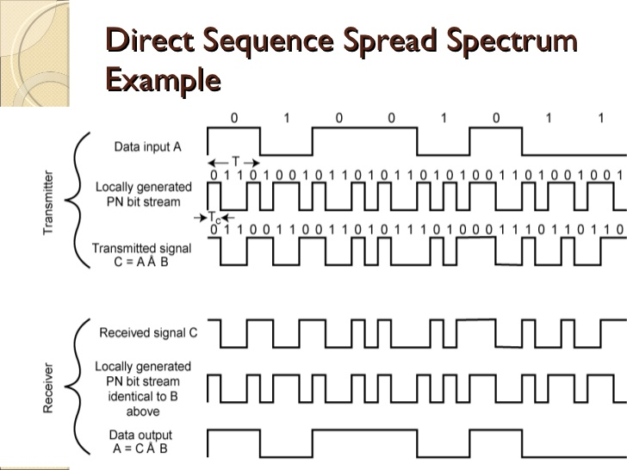

4.
b.
Amplitude Shift Keying (ASK) is a type of Amplitude Modulation which represents the binary data in the form of variations in the amplitude of a signal.
Any modulated signal has a high frequency carrier. The binary signal when ASK modulated, gives a zero value for Low input while it gives the carrier output for High input.
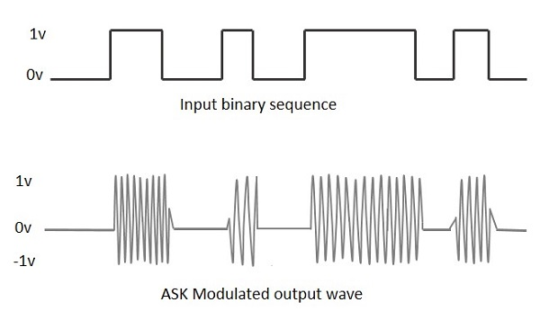

Frequency Shift Keying (FSK) is the digital modulation technique in which the frequency of the carrier signal varies according to the digital signal changes. FSK is a scheme of frequency modulation.
The output of a FSK modulated wave is high in frequency for a binary High input and is low in frequency for a binary Low input. The binary 1s and 0s are called Mark and Space frequencies.

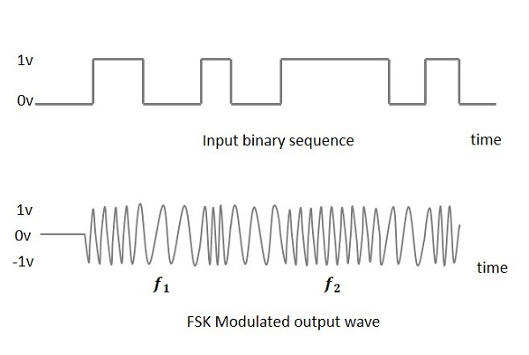

Phase Shift Keying (PSK) is the digital modulation technique in which the phase of the carrier signal is changed by varying the sine and cosine inputs at a particular time. PSK technique is widely used for wireless LANs, bio-metric, contactless operations, along with RFID and Bluetooth communications.

C.
Pulse code modulation (PCM)
Pulse code modulation (PCM) is a digital scheme for transmitting analog data. The signals in PCM are binary; that is, there are only two possible states, represented by logic 1 (high) and logic 0 (low). This is true no matter how complex the analog waveform happens to be. Using PCM, it is possible to digitize all forms of analog data, including full-motion video, voices, music, telemetry, and virtual reality (VR)

Delta Modulation
The type of modulation, where the sampling rate is much higher and in which the step size after quantization is of a smaller value Δ, such a modulation is termed as delta modulation.

Quadrature amplitude modulation
Quadrature amplitude modulation (QAM) is a method of combining two amplitude-modulated (AM) signals into a single channel, thereby doubling the effective bandwidth. QAM is used with pulse amplitude modulation (PAM) in digital systems, especially in wireless applications.

